Extended abstract title: boldface Times New Roman, 14 pt, non-capitalized words, Style „IAMG_Title“

F. AUTHOR^{1*} and S. AUTHOR²

¹Department - Institution, Country, email@university.edu (email of presenting author, not necessarily the first one)
²Department - Institution, Country (Times New Roman, 10pt)
*presenting author

Abstract
This is the place for a minimal abstract if you wish to have one in your extended abstract contribution. It should be 10pt, an extra 1cm margin on both sides, and it is not recommended to have more than 10 lines. You can use the style „IAMG_abstract“ for it. The institutions of the authors can also be formatted with a centered „IAMG_abstract“ style.

1 An example of section for the full paper (Style „IAMG_section1“)

The length of full papers should be at least 4 pages, at most 10 pages (filesize 2Mb or less), text Times New Roman 11 pt, with first-line indented, fully justified paragraphs, single line spacing, 2 cm margins. Formulae, figures and tables are possible (caption not least than 10 pt). Submit a PDF with embedded fonts, to ensure format invariance. This is the place for a minimal abstract if you wish to have one in your extended abstract contribution. It should be 10pt, an extra 1cm margin on both sides, and it is not recommended to have more than 10 lines. The style is „IAMG_text“.

1.1 And a subsection (Style „IAMG_subsection2“)

1.1.1 Even a subsubsection is possible (Style „IAMG_subsubsection3)

Full papers follow the same template as abstracts, with regard to paper size (a4), margins (2.54cm each), font size and type (Times New Roman 11pt) and further details. Figures and tables must have a caption. Cite them as normal, e.g. Figure 1 and Table 1. The first paragraph of each section should not be indented, but the following lines should. Citation schemes should follow the Chicago conventions, i.e. both author (year) as in Aitchison (1986) or else (author, year) styles may be used. For one or two authors, both names should appear (Pawlowsky-Glahn and Egozcue, 2001). For three or more authors, use the first name followed by et.al., like in Templ et al. (2011).

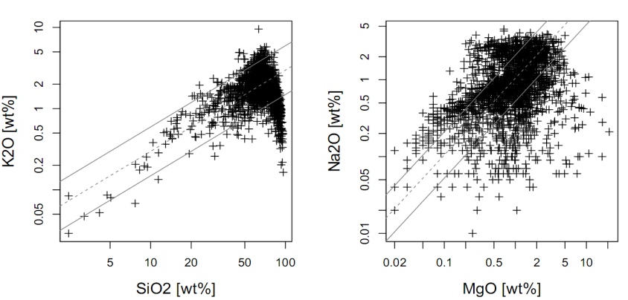

Figure 1. one line-caption: a centered “IAMG_asbtract style” can serve

Country | red meat | white meat | Eggs
Ablandia | 10.1 | 1.4 | 0.5
Cedenia | 8.9 | 14.0 | 4.3
Fagalia | 13.5 | 9.3 | 4.1

Table 1: Example of a table. Lines should be used reasonably, for instance to separate header from the main table body and to close the table itself. Captions of figures and tables (FLOATS) of one single line can be produced by a centered „IAMG_Abstract“ style. Float captions of more than one line has the style „IAMG_LongCaptionFloat“.

References (Style „IAMG_section1“, no numbering)

Aitchison, J. (1986). The Statistical Analysis of Compositional Data. Monographs on Statistics and
Applied Probability. Chapman & Hall Ltd., London (UK). (Reprinted in 2003 with additional
material by The Blackburn Press). 416 p.

Pawlowsky-Glahn, V. and J. J. Egozcue (2001). Geometric approach to statistical analysis on the
simplex. Stochastic Environmental Research and Risk Assessment (SERRA) 15 (5), 384-398.

Templ, M., K. Hron, and P. Filzmoser (2011). robCompositions: an R-package for robust statistical
analysis of compositional data. In V. Pawlowsky-Glahn and A. Buccianti, editors, Compositional
Data Analysis. Theory and Applications. John Wiley & Sons, Chichester (UK), pp. 341-355.

